API call for student UIC service
  - v2

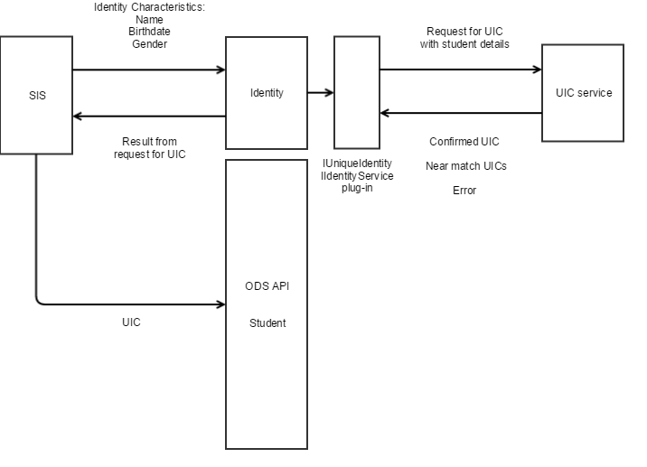

This documentation is not authoritative regarding the procedures used to create or update identity information in the State UIC service.
Refer to and follow official state policies and procedures when creating/updating identity information.

The Ed-Fi ODS API contains an identity service endpoint that was intended to be used as an abstraction when working with state identity services. This service provides an interface that supports the following capabilities:
- Lookup identity identifier by identity characteristics
- Verify identity information with identity identifier and identity characteristics
- Retrieve basic identity information by unique identity identifier
- Create identity identifier with identity characteristics
Of these capabilities, the first two are very similar and are implemented in the same API method.
An identity identifier is a single alphanumeric value that is used to uniquely identify a person within the state education systems. In Michigan, this value is known as the Unique Identification Code or UIC. In Ed-Fi parlance, it is referred to as the Unique Identifier or UniqueId.
Identity characteristics are other pieces of information that can be used to uniquely identify a person. These values include: name, birth date, birth gender, birth order, and other available identifiers (such as local education agency identifier number, state or federal identification numbers (or partial numbers), or possibly lookup numbers to bio-metric characteristics. These values alone may not be sufficient to uniquely identify an individual; ambiguous matches may be resolved by referencing other information collected from other systems or agencies.
To integrate a state identity service (such as the CEPI UIC Service) with the Ed-Fi ODS Identity API, a software plug-in is written that implements the IUniqueIdentity and/or IIdentityService interfaces. When this plug-in is registered in the Ed-Fi ODS API, it is used as the application logic for the identity APIs. Providing standard APIs for identity information reduces the integration complexity for SIS vendors.
A Student Information System (SIS) typically interacts with the Identity API in the following manner:
- A student enters the SIS without a UIC
- The SIS uses identity information that is available with the person information to call the Identity API and retrieve possible UIC values.
- If a single exact match is found, it is attached to the SIS person record as the state identifier (or similar).
- If a one or more near-matches are found (no exact matches are returned from the Identity API):
  - The correct identity characteristics are verified
  - The information in the SIS is updated with corrected information
  - If the UIC information is out of date due to name changes, missing alternate identifiers, etc. then an "update identity request" is sent to the UIC service based on official documentation of the change.
- If no near-matches provide correct identity information, a "new identity request" is sent to the UIC based on official documentation.
The Identity API may also be used to verify incoming identity information from other sources. In this case, the UIC/UniqueId is provided along with some subset of identity characteristics. Each set of identity information is submitted to the Identity API, and exact matches are expected.
The Michigan UIC Service contains an asynchronous interface capable of handling bulk requests. This capability was not anticipated by the original design of the Ed-Fi ODS API. The Ed-Fi ODS API Identity service is being augmented with additional bulk/batch capabilities contained in the Identity2 API. This addition has been provided to the Ed-Fi Alliance in a pull-request for inclusion in a future version of the Ed-Fi ODS API.
Some fields do not map directly between the UIC service demographic info and Ed-Fi ODS API; the following table is a summary of these mappings:
UIC | Identities | Identities2
FirstName | GivenNames | FirstName
MiddleName | GivenNames | MiddleName
LastName | FamilyNames | LastSurname
LastNameSuffix |  | GenerationCodeSuffix
Gender | BirthGender | SexType
DateOfBirth (string) | BirthDate (date) | BirthDate (date)
MultipleBirthOrder |  | BirthOrder
LocalIdentifier | Identifiers[] | IdentificationCodes[]
 |  | OtherNames[]
 |  | Enrollments[]
MatchConfidence | IsMatch, Weight | Score
A few notes:
- Empty cells in the table indicate that there is no corresponding value
- DateOfBirth is converted to/from a DateTime value
- FirstName-> the first value in GivenNames
- MiddleName -> the second value in GivenNames
The Michigan UIC system and Ed-Fi Identities API also support different operations:
UIC | Identities | Identities2 | Description
 | GetById | GetById | Retrieve identity information by providing a UIC
GetInformationByUICMatching |  |  | Retrieve basic identity information by matching search
GetDetailedInformationByUICMatching | GetByExample | Search | Retrieve detailed identity information by matching search
 | Post | CreateIdentity | Create a new identity in the identity system
 |  | SearchByIds | Retrieve multiple identity information results by providing UICs
GetRequestIdForUICMatching |  | SearchByCriteria | Provide search criteria for an asynchronous search
GetInformationFromRequestId |  |  | Retrieve basic identity information from an asynchronous search token
GetDetailedInformationFromRequestId |  | SearchResult | Retrieve detailed identity information from an asynchronous search token
Items in bold are APIs that deal with multiple identities.

